First we create all the data in **PlayerDetails.js,**

**PlayerDetails.js**

const players = [

    {

        name: "Sachin",

        score: "100",

    },

    {

        name: "Rohit",

        score: "75",

    },

    {

        name: "Bumrah",

        score: "46",

    },

    {

        name: "Hardik",

        score: "55",

    },

    {

        name: "Gill",

        score: "72",

    },

    {

        name: "Virat",

        score: "95",

    },

    {

        name: "Jadeja",

        score: "65",

    },

    {

        name: "Choudhary",

        score: "60",

    },

    {

        name: "Dhoni",

        score: "99",

    },

    {

        name: "Sourav",

        score: "68",

    },

];

const T20Players = ['First Player', 'Second Player', 'Third Player'];

const RanjiTrophyPlayers = ['Fourth Player', 'Fifth Player', 'Sixth Player']

export default players;

export const IndianPlayers = [...T20Players, ...RanjiTrophyPlayers];

**App.js**

import './App.css';

import Home from './Home';

function App() {

  return (

    <div className="App">

      <Home />

    </div>

  );

}

export default App;

**Home.js**

import React from "react";

import ListOfPlayers from "./ListOfPlayers";

import ScoreBelow70 from "./ScoreBelow70";

import OddPlayers from "./OddPlayers";

import { IndianPlayers } from "./PlayerDetails";

import EvenPlayers from "./EvenPlayers";

import players from "./PlayerDetails";

import ListOfIndianPlayers from "./ListOfIndianPlayers";

const Home = () => {

  var flag = true;

  if (flag == true) {

    return (

      <div>

        <h1>List of Players</h1>

        <ListOfPlayers players={players} />

        <hr />

        <h1>List of Players having Scores less than 70</h1>

        <ScoreBelow70 players={players} />

      </div>

    );

  } else {

    return (

      <div>

        <div>

          <h1>Indian Team</h1>

          <h1>Odd Players</h1>

          {OddPlayers(IndianPlayers)}

          <hr />

          <h1>Even Players</h1>

          {EvenPlayers(IndianPlayers)}

        </div>

        <hr />

        <div>

          <h1>List of Indian Players Merged: </h1>

          <ListOfIndianPlayers IndianPlayers={IndianPlayers} />

        </div>

      </div>

    );

  }

};

export default Home;

**ListOfIndianPlayers.js**

import React from "react";

const ListOfIndianPlayers = ({ *IndianPlayers* }) => {

  return (

    <div>

      {IndianPlayers.map((*player*) => (

        <div>

          <li>{player}</li>

        </div>

      ))}

    </div>

  );

};

export default ListOfIndianPlayers;

**ListOfPlayers.js**

import React from "react";

const ListOfPlayers = ({ *players* }) => {

  return (

    <div>

      {players.map((*player*) => (

        <div>

          <li>

            Mr. {player.name} <span>{player.score}</span>

          </li>

        </div>

      ))}

    </div>

  );

};

export default ListOfPlayers;

**OddPlayers.js**

import React from "react";

const OddPlayers = ([*first*, , *third*, , *fifth*]) => {

  return (

    <div>

      <li>First: {first}</li>

      <li>Third: {third}</li>

      <li>Fifth: {fifth}</li>

    </div>

  );

};

export default OddPlayers;

**EvenPlayers.js**

import React from 'react'

const EvenPlayers = ([,*second*, , *fourth*, , *sixth*]) => {

    return (

        <div>

            <li>second: {second}</li>

            <li>fourth: {fourth}</li>

            <li>Sixth: {sixth}</li>

        </div>

    )

}

export default EvenPlayers

**ScoreBelow70.js**

import React from "react";

const ScoreBelow70 = ({ *players* }) => {

  return (

    <div>

      {players.map((*player*) =>

        player.score < 70 ? (

          <div key={player.name}>

            <li>

              Mr. {player.name} <span>{player.score}</span>

            </li>

          </div>

        ) : (

          ""

        )

      )}

    </div>

  );

};

export default ScoreBelow70;

**OUTPUT:**

When **flag = false**

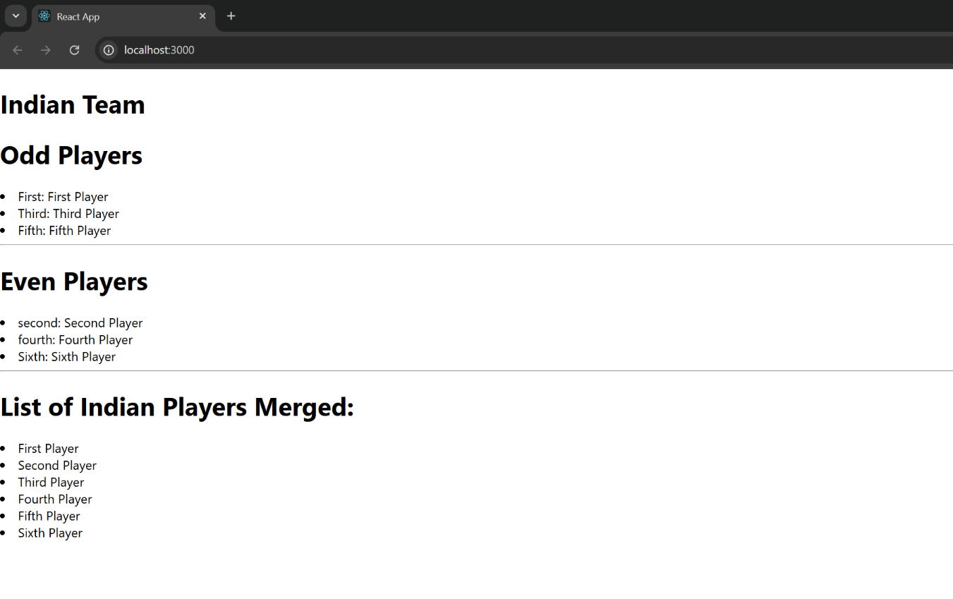

When **flag = true**

